Mantid
PM report to Project Management Board
3rd April 2014
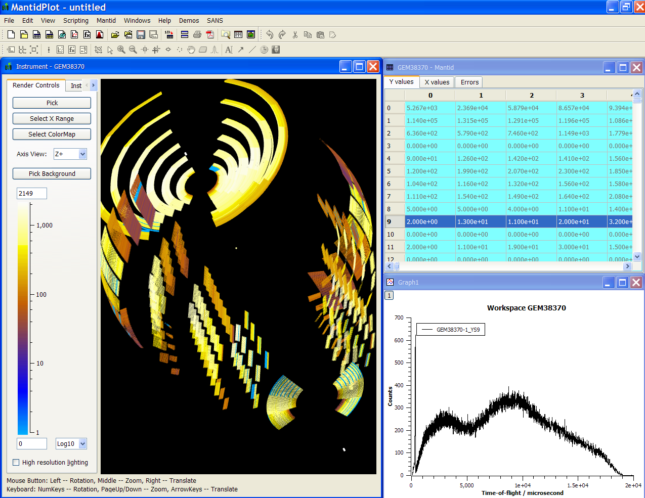
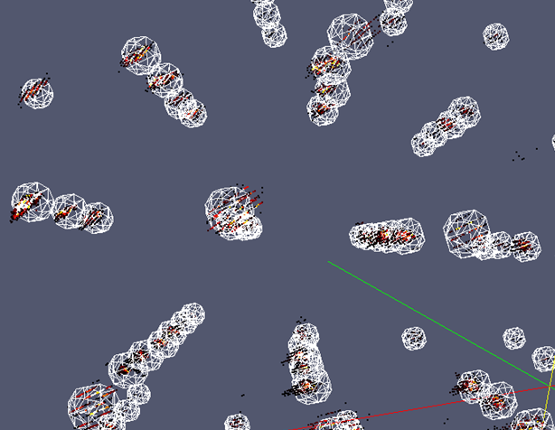
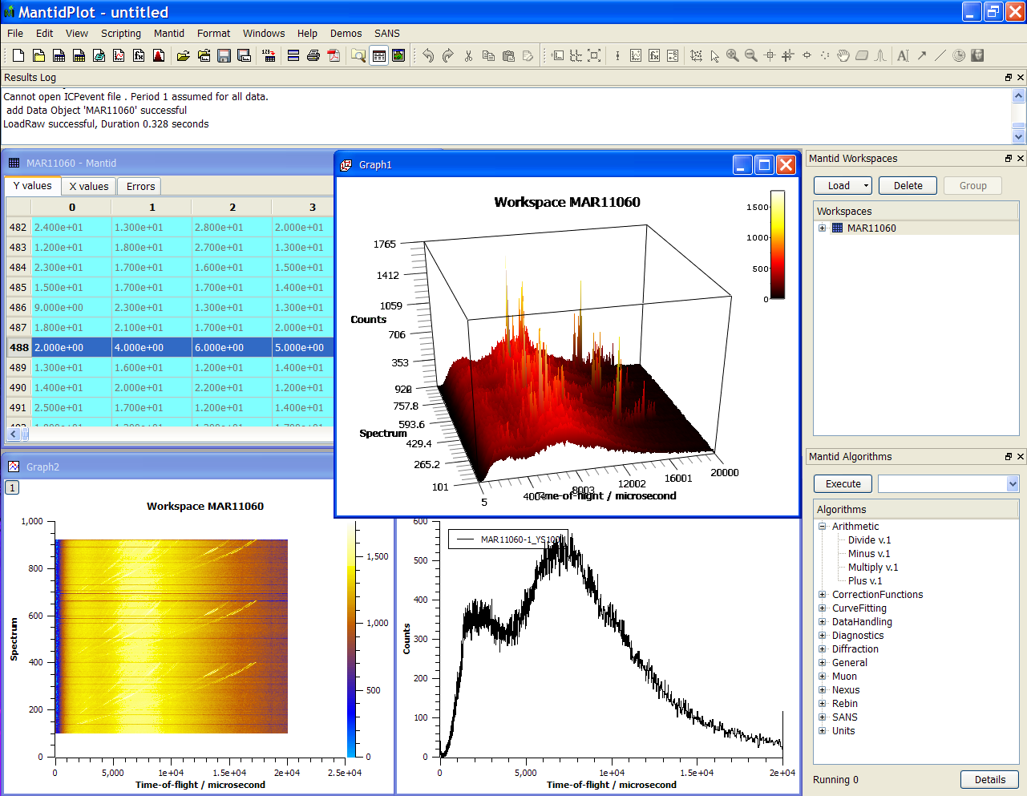
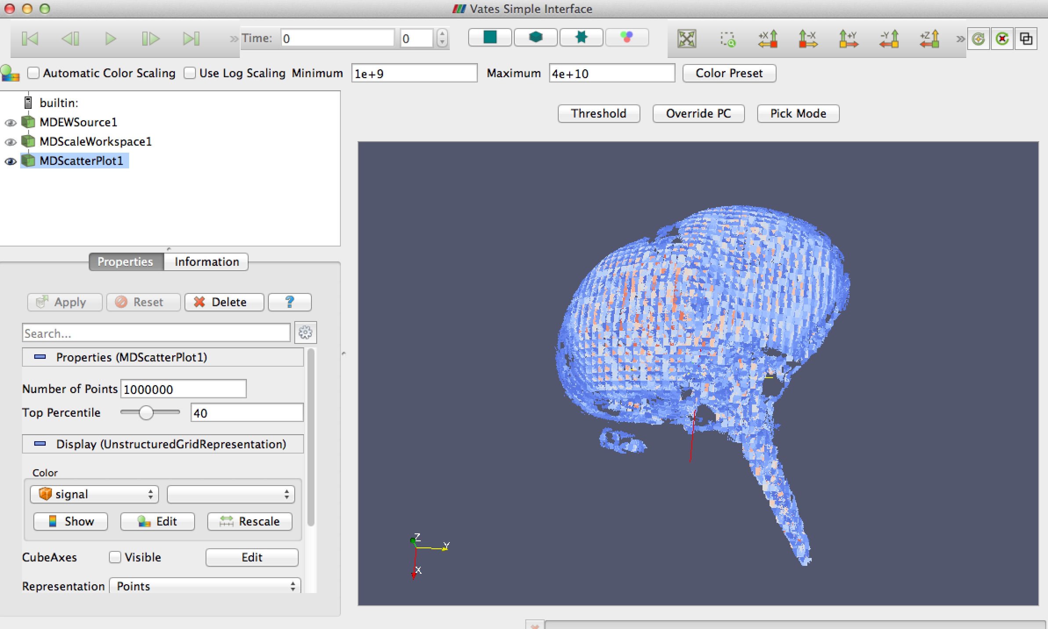
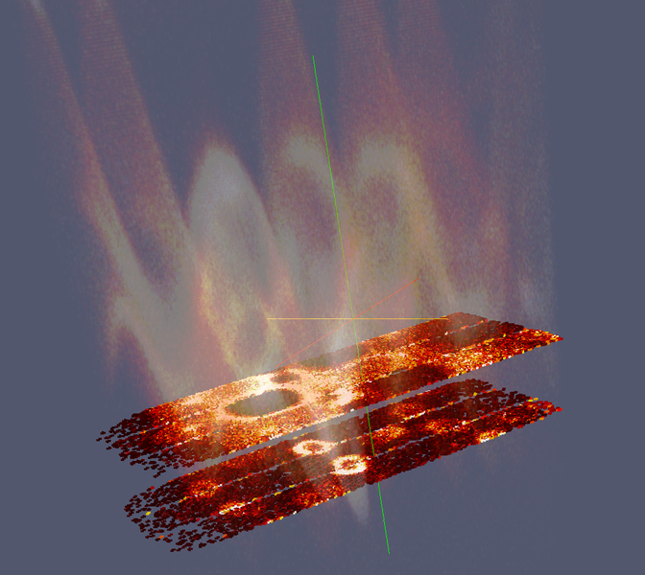
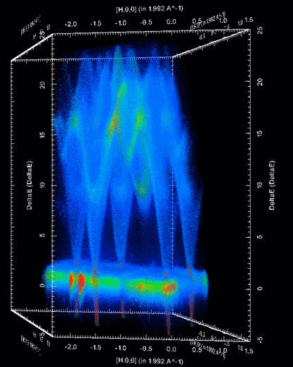

Document Control
This document is under document control. All members of the distribution list will receive updated copies whenever alterations are made. All other copies are uncontrolled.

Contributors
Name | Role | Company
Nicholas Draper | Author | Tessella

Document Approval
Name | Role | Company

Distribution
Name | Role | Company
Project Management Board Members | Recipient | STFC & ORNL
Mantid Project Repository | Filing | STFC & ORNL

Revision History
Author | Issue | Date | Description
Nicholas Draper | V1.R1.M0 | 31-Mar-2014 | 1st version written

References
Document | Ref | Date | Details and Version
Project Specification | [PS] |  | https://github.com/mantidproject/documents/blob/master/Project%20Management/ProjectSpecification.doc?raw=true
Stakeholder Plan | [SP] |  | https://github.com/mantidproject/documents/blob/master/Project%20Management/StakeholderPlan.doc?raw=true
Risk Register | [RR] |  | https://github.com/mantidproject/documents/blob/master/Project%20Management/RiskRegister.xls

Table of Contents
1 Introduction 3
2 Minutes of the previous meeting 4
3 Project Documentation 4
4 Project Status 5
5 Changes to supported Operating Systems 5
6 Referencing Mantid, DOIs and the approval of the Mantid Paper 5
7 Mantid Governance model 5
8 Report of the Technical Standard Committee 5
9 Update on interest from other facilities, and existing collaborations 6
10 Future Release Dates 7
11 Appendix A 8

Introduction

Purpose of this Document
This report details the current state of the Mantid project and presents the agreed agenda for discussion. The project management board will use the information in this report as a basis for the meeting.

Scope of this Document
The scope of this document is limited to the Mantid project, both for progress up to the meeting of the Project management board, and plans for the future.

Context of this Issue
This is the twelfth project management report to the Mantid project management board and will provide input to the meeting.

Minutes of the previous meeting
The minutes of the previous meeting are available here:
https://github.com/mantidproject/documents/blob/master/Project%20Management/PMB/Minutes/PMCMinutes24thJanuary14.docx?raw=true

Project Documentation
The project documentation is available through the links below. The Risk Register has been reviewed and updated. The other documents have not been changed since the last PMB meeting.

Stakeholder Plan:
https://github.com/mantidproject/documents/blob/master/Project%20Management/Stakeholder Map.doc?raw=true
Reviewed and not changed

Risk Register:
https://github.com/mantidproject/documents/blob/master/Project%20Management/RiskRegister.xls
Updates:
Reviewed and one new risk added

No. | Description | Risk Type | Impact | Probability | Current Controls in place | Additional Action to be Taken  or Contingency Plan
33 | Cloud server instance fails to provide sufficient build server performance | Operational | Significant | Moderate | Benchmarking before entering active usage. Reporting of slow access / instability by dev team. | Upgrade to a more powerful instance, revert to separate Jenkins instances if necessary.

Project Status

Development Progress
Since the last PMB meeting in January 2014 we have completed one development iterations and released new versions of Mantid on the following dates:
- v3.1 7th Feb 2014
- v3.1.1 28th Feb 2014
Development continues at a good pace: see the project metrics in section 12.2.

Changes to supported Operating Systems

32 Bit Windows
As discussed at the last PMB we are no longer planning on supporting 32 bit Windows. This was raised at the release demonstrations in February.

Windows 7 64 bit
We have started getting user requests for windows 7 installations, and encountered our first Windows 7 specific bug. We propose to start looking into supporting Windows 7.1 64 bit as an official supported environment.
To Decide: Are these approved?

Referencing Mantid, DOIs and the approval of the Mantid Paper

Mantid Paper
The Mantid paper has now been submitted to Nuclear Instruments and Methods in Physics, the following people were suggested as reviewers.
- Dr. Raymond Osborn
- Prof. Brent Fultz
- Prof. Simon Billinge
- Dr. Nick Hauser
- Dr. Yasuhiro Inamura

Mantid Governance model
The proposal for the Governance model has been updated and circulated with this report and is also available here. Areas with red text have been recently changed or added.

To Decide: For the areas highlighted in Yellow are those levels suitable?
To Decide: Is this acceptable?

Report of the Technical Standard Committee
The terms of references had been agreed and are available here
https://github.com/mantidproject/documents/blob/master/Project%20Management/TechnicalSteeringCommittee/TSC-Terms.md
The first meeting has been held, and here are the things that have been considered, or are undergoing consideration:
- The impact of supporting RHEL6 compared to other linux distributions
- The approval of an offer to Michael Wedel to become a “Selected Developer”
- Proposed designs for:
  - Automated Instrument definition updates
  - Nested Algorithm Histories
- Integrating pull requests from the PSI

Update on progress of SSC requirements
Started in Release 3.1
id | summary | owner
In progress
8917 | Documentation Maintenance | Karl Palmen
Design & review
8913 | History depth / extracting scripts | Samuel Jackson
8922 | Load performance History | Samuel Jackson
8924 | Repo. for instrument files | Russell Taylor
Investigation
8911 | MultiDataFitting | Jose Borreguero
8916 | Improve vates visualisation defaults | Michael Reuter
8912 | Python Command Line interface improvements | Owen Arnold
8909 | Tiled Graph Displays | Roman Tolchenov
8914 | Masking redesign | Nick Draper
8932 | Mslice interface | Steve Miller
8926 | Multiple scattering sub project - outline document | Jon Taylor
Queued
8915 | GUI design guidelines | Martyn Gigg
8918 | Algorithm naming conventions/standards | Martyn Gigg
8919 | Better usage examples in documentation | Anders Markvardsen
8923 | Plotting improvements | Martyn Gigg
8925 | Specify API for instrument control | Nick Draper
8929 | refl benchmarks | Jean Bilheux
8930 | Fix rectangular detector issues | Peter Peterson
8945 | Measure loading performance for large files and optimize | Stuart Campbell
To be started in Release 3.2
id | summary | owner
8927 | Verification of the ISIS quick scripts (with liquids) | Peter Peterson
8928 | Unify ISIS refl simple UI to work everywhere | Owen Arnold

Update on interest from other facilities, and existing collaborations

ILL
The Bastille project did not receive funding Ricardo Ferraz Leal who has done most of the work thus far is leaving at the end of his temporary contract and will be replaced by Yannick Raoul. Mantid can support direct, indirect and small angle instruments at the ILL and some work is ongoing with Reflectometry. Mark Johnson is interested in organising a Mantid tutorial, perhaps in June.

J-Parc
No further contact, will follow up at the the NOBUGS meeting is at J-Parc.

ANSTO
The new SANS instrument BILBY at ANSTO will use Mantid, David Mannicke is providing support from ANSTO as a contributor.

ESS
A formal request has been made to join, this is waiting on the approval of the Governance model.

CSNS
Julian Tao attended our developer workshop, and the CSNS have signed an MOU with ISIS for knowledge sharing. They wish to become members of the collaboration, and are waiting on approval governance model.

PSI
Mark Koernicke has employed a member of staff Michael Wedel to work with Mantid support of their instruments. He has started with POLDI and he has contributed very high quality contributions the TSC agreed to offer him selected developer status, he is discussing this with his management. Mark himself continues to be involved but at a lesser level.

Future Release Dates
The planned release dates for the rest of this year and next would be:
- v3.2 2nd May 2014
- v3.3 8th August 2014
- v3.4 7th November 2014
This does not include patch releases.
To Decide: Is this acceptable?

Appendix A

Project Metrics
The code metrics are independently generated and displayed here
http://www.ohloh.net/p/Mantid/analyses/latest/languages_summary
Total Lines : | 2,614,401 |  | Code Lines : | 1,983,660 |  | Percent Code Lines : | 75.9%
 |  |  | Total Comment Lines : | 349,191 |  | Percent Comment Lines : | 13.4%
 |  |  | Total Blank Lines : | 281,550 |  | Percent Blank Lines : | 10.8%

Ticket completion rate
Development on Mantid is performed in three month iterations, each of which ends with an official release of the software. Longer pieces of work sometimes have to span a development iteration in which case that piece of work appears as completed only in the iterations when it becomes available to the users.
The patch releases (2.x.x) are very much smaller and are used to solve issues that become apparent after the main release or release urgent improvements that have recently been added.

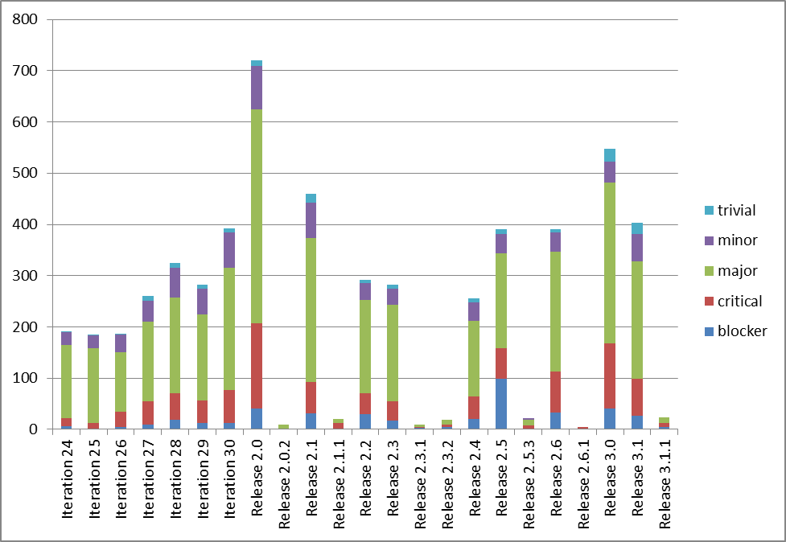
The Release 2.0 appears out of proportion beacause it covered two development iterations (6 months of effort).

Project Uptake

Mailing List Subscriptions
Our software download site no longer requires people to register to a mailing list in order to download the installer packages. A simple analysis of the email domains shows that while the majority of the users are from ISIS, followed by ORNL and we have had some interest from other institutions and universities.
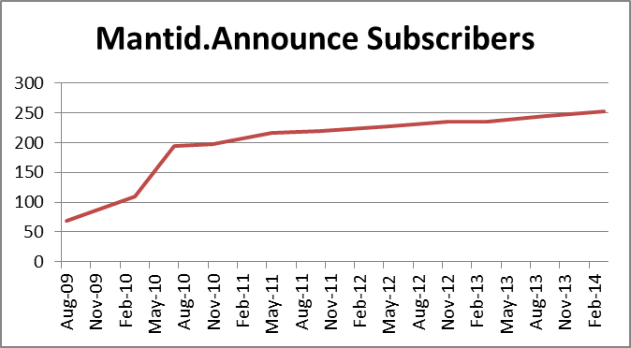
Summary
Date | Users
Aug-09 | 68
Mar-10 | 109
Jul-10 | 195
Nov-10 | 197
May-11 | 217
Oct-11 | 219
May-12 | 228
Nov-12 | 235
Mar-13 | 235
Sep-13 | 245
Mar-14 | 252

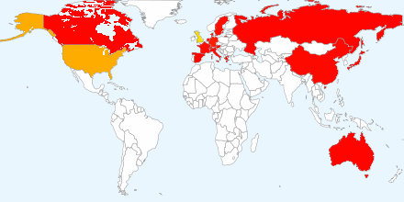
Current domain breakdown (2+)
Unique domain | count
stfc.ac.uk | 73
ornl.gov | 30
gmail.com | 22
helmholtz-berlin.de | 9
psi.ch | 3
ill.fr | 3
swansea.ac.uk | 2
sheffield.ac.uk | 2
imperial.ac.uk | 2
caltech.edu | 2
esss.se | 2
owlpic.com | 2
fz-juelich.de | 2
tudelft.nl | 2
isc.cnr.it | 2
open.ac.uk | 2
physics.ox.ac.uk | 2
anl.gov | 2
hotmail.com | 2
bath.ac.uk | 2
uwstout.edu | 2
ansto.gov.au | 2
clemson.edu | 2
hmi.de | 2
ihep.ac.cn | 2
lanl.gov | 2

